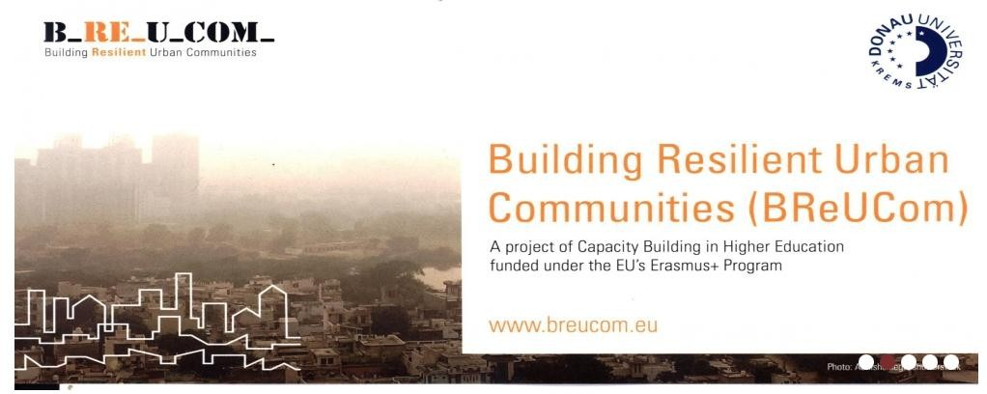

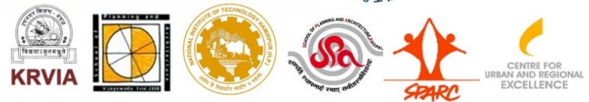

A PROJECT FUNDED UNDER EU ERASMUS+ PROGRAM IN THE FIELD OF CAPACITY BUILDING IN HIGHER EDUCATION

The increased frequency of natural hazards and sea level rise are expected impacts of climate change in India. Marginalized urban settlements are often vulnerable to disaster due to their location in hazardous areas and the use of non-durable building materials, already today their inhabitants are therefore strongly affected by climate change. But amidst strives to meet climate targets, the poor’s needs are mostly overlooked.

In this context, there is an urgent need for paradigmatic shift in the education of graduate students in spatial planning and design as well as training of urban professionals from different backgrounds in order to confront upcoming challenges related to climate change impacts on urban informal settlements.

The BReUCom project conceives and pilots postgraduate short-term Professional Development Programs (PDPs) targeted at real world problems.

BReUCom therefore will:

- Produce Open Educational Resources by developing 10 comparative case studies & 10 descriptions of new courses for graduate students in existing programs, following MIT’s Open Courseware model
- Pilot 5 new courses on urban resilience in existing curricula for graduate students
- Develop 20 new Professional Development Programs (PDP's) modules on urban resilience for urban professionals from different backgrounds and working experiences, pilot 10 modules including internships with NGOs in India and Europe.

TIMELINE | 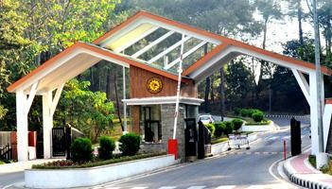 From January 2019 to January 2022
COUNTRIES | Austria, India, Netherlands
FUNDED BY | Erasmus+ Programme of the European Union
PROJECT TEAM | Dr Inderpal Singh  Dr Puneet Sharma  Dr Aniket Sharma

BReUCom is implemented by a consortium led by Danube University Krems (Austria) and includes the following partners:
- ITC, University of Twente, Enschede, The Netherlands
- Kamla Raheja Vidyanidhi Institute for Architecture and Environmental Studies, Mumbai, India
- School of Planning and Architecture, Vijayawada, India
- National Institute of Technology, Hamirpur, India
- School of Planning and Architecture, Bhopal, India
- Society for Promotion of Area Resource Centres, Mumbai, India
- Centre for Urban and Regional Excellence, Delhi, India

FOR MORE INFORMATION VISIT:

https://www.breucom.eu
https://www.breucom.org

