**Electrical Engineering Department**

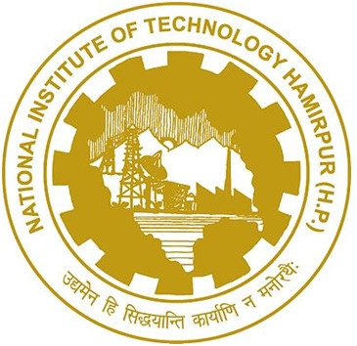Skill Development Programme conducted by Electrical Department NIT Hamirpur under TIFAC-CORE developed a skill development centre in collaboration with industrial financial partner H.P. State Electricity Board Shimla on Power Diagnostics and has also conducted various programmes to upgrade the technical knowledge of staff of HPSEB.

National institute of Technology Hamirpur is one of the thirty first NITs of the country established in 1986 as regional engineering college and converted into National Institute of Technology, Hamirpur (NITH). It is an institute of national importance and imparts quality technical education at undergraduate level in civil engineering , computer science and engineering, Electrical and Electronics Engineering, Electronics and Communication Engineering, Mechanical Engineering, Chemical Engineering, Architecture, Apart from engineering undergraduate program , NITH also offers Post graduate, Dual degree in various streams of Doctorate Education in engineering, science and humanities .The institute aims to create technical manpower in various engineering areas of importance for nation and also contribute to latest growing technological and professional excellence.

**Objectives of “Skill India”**

The objective of this scheme is to encourage skill development for youth by providing monetary rewards for successful completion of approved training programs. Especially scheme aims to:

* Encourage standardization in the certification process and initiate process of creating a registry of skills.
* To provide monetary awards for skill certification to boost employability and productivity of youth by incentivizing for skill training.
* Increase productivity of the existing workforce and align the training and certification to the needs of the country.

**Vision**

* Creation of 500 million skilled manpower by 2022.
* Inclusive skill development irrespective of any divide – Gender, Rural/Urban, organized/ unorganized industry, Traditional home based/contemporary work place based.

**Need of Skill Development**

* Only 5% of existing workforce trained and more than 80% are without any formal training.
* Enhancement in training facilities.
* Identification of skill gaps and improvement in employability.
* Alignment of skill set with market requirement.
* Developing training packages reflecting industry needs.
* Skills development tools, including e-learning.



1. 03 day STC on Emerging Trends in Power transformer engineering during 06-08 Sept 2014 for Senior Engineers, Executives of HPSEB Ltd. Shimla.
2. 03 day STC on Condition monitoring of Electrical Apparatus during 25-27 Nov 2014 for Junior Engineers, SSA of HPSEB Ltd. Shimla.
3. 03 day STC on Condition monitoring of Electrical Apparatus during 29-31 Dec 2014 for Junior Engineers, SSA of HPSEB Ltd. Shimla.
4. 03 day STC on Condition monitoring of Electrical Apparatus during 22-24 Sept 2015 for Junior Engineers, SSA of HPSEB Ltd. Shimla.
5. 03 day STC on Condition monitoring of Electrical Apparatus during 28-30 Oct 2015 for Junior Engineers, SSA of HPSEB Ltd. Shimla.

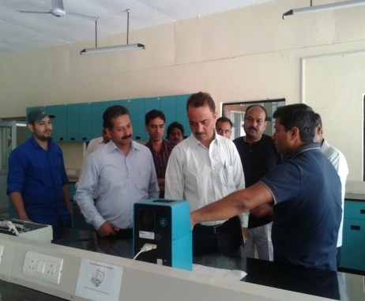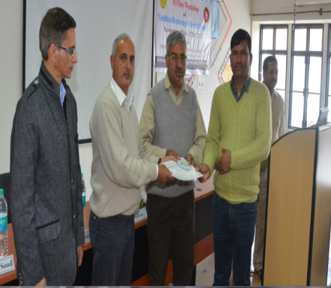

**Computer Science & Engineering And Computer Centre**

Department of Computer Science and Engineering organized a one day Training Programme on 3rd Oct, 2015 for the benefit of students of NIT Hamirpur. Resource persons from CDAC (Mr. Navedeep Singh Chahal-CDAC Mohali, Mr. Ch. A.S. Murthy-CDAC Hyderabad, Mr. Hari Babu-CDAC Bangalore, Mr. Sunil K. Chillar-CDAC Mohali, and Mr. Harpreet Singh-CDAC Mohali) imparted training in the area of Information Security, Internet of Things, and Cloud Computing. More than 100 students attended the training programme. Coordinated by Dr. Narottam Chand and Dr. Naveen Chauhan.

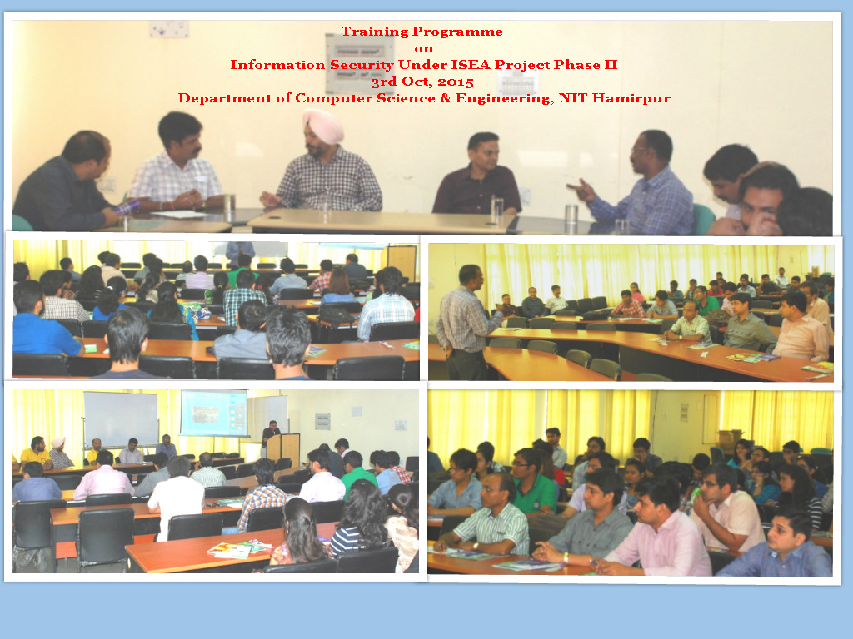

**Department Of Management Studies**

Department of management studies, NIT, Hamirpur in its maiden attempt successfully organised a two days workshop from 18-19 December, 2015 on “Shaping the art of scholarly writing in Engineering and Management: A Discursive Approach under the aegis of “Skill India” or young faculty, PG students or research scholars. The aim of workshop was to ensure that youth with formal education are employable wit job oriented skills, so as to equip them to meet a valuable contribution to existing knowledge and to facilitate them to take a great deal of diligence, organisation willingness and most importantly update the skill for writing.

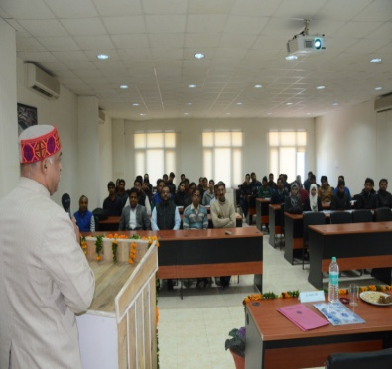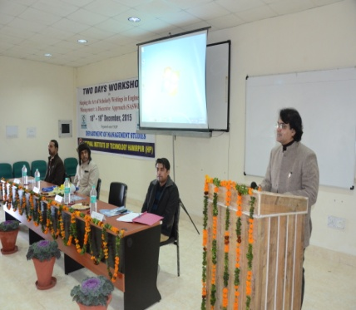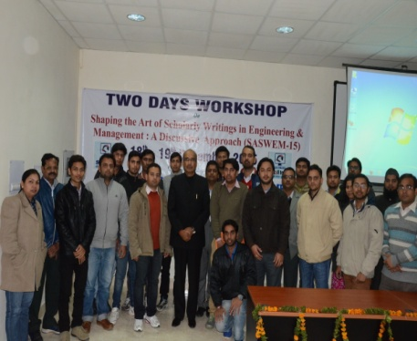

**Mechanical Engineering Department**

Mechanical Engineering Department NIT, Hamirpur under utilization of infrastructural facilities for endeavours in delivery of academic programmes and research activities.

Following courses were conducted under skill development programme to aware about latest technology to staff of NITH and ITIs in Himachal Pardesh:

1. Course on engineering measurements from 16th to 20th Dec, 2013 for technical staff of NITH.
2. Short term course on Fitter, Turner, Machinist, Tool Die Maker w.e.f 30th June – 5th July, 2014.
3. Short term course on Welding Technology 7th – 11th July, 2014
4. Short Term Training Programme for HP Govt. ITI Staff on Motor Mechanic and Diesel Mechanic w.e.f. 14-07-2014 to 19-07-2014

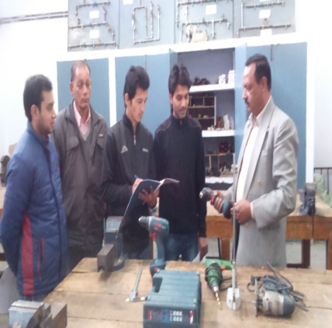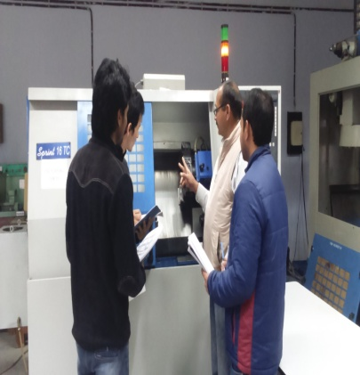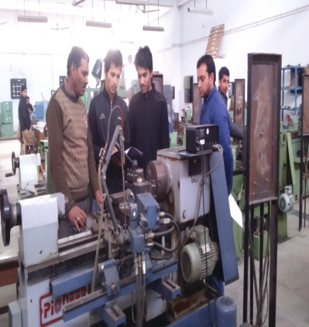

**Skill India Programme in the Central Workshop in December, 2016**

Awareness programme on latest technology development were organized under Skill India to trainees of Govt. Industrial Training Institute Nadaun at Rail, Distt. Hamirpur in Central Workshop, NIT Hamirpur (HP) as per detail listed below.

1. Awareness programme on latest technology to Fitter trade ITI students was conducted on 23rd December, 2016. Students were made aware about working and principle of hand power operated tools like Jig saw, Saber saw, Impact wrench, Cordless screw driver, Angle grinder & High speed cut of saw.

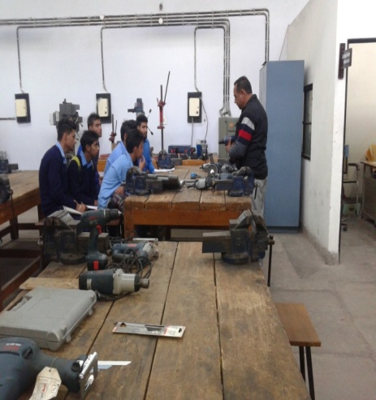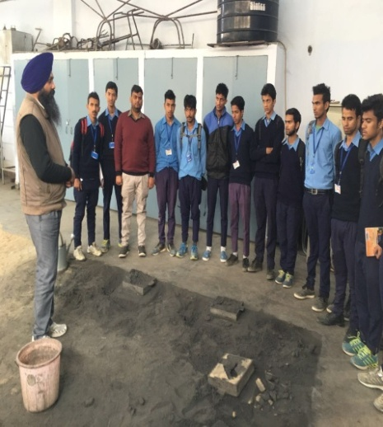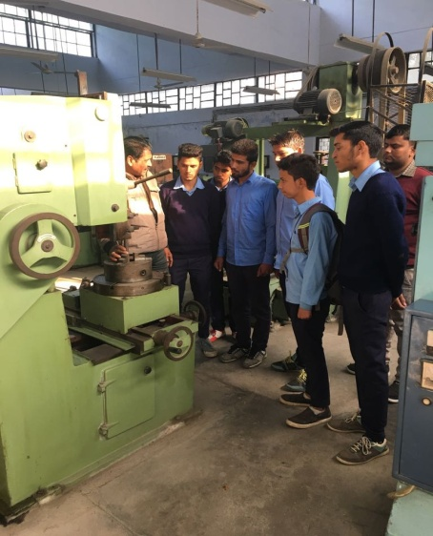

1. Awareness programme on latest technology to Machine trade ITI students was conducted on 26th December, 2016. Students were made aware about working of latest machine tools like CNC lathe and DRO lathe and Gear hobbing machine.

